Fixes and changes.

1. Please add a “request and invoice” button besite the “Pay now by Debit or Credit card” Button.

When an employer selected this button. It would send an email to [Info@seasonalstaff.co.nz](mailto:Info@seasonalstaff.co.nz) In that email would be the email details and the annual membership selection they had choosen. Eg “ Needing 1-50 staff”

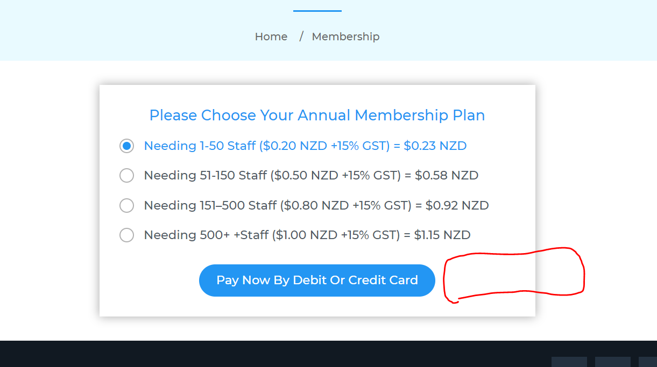

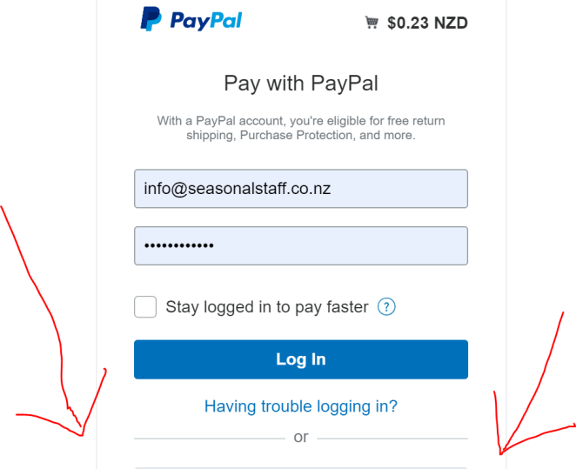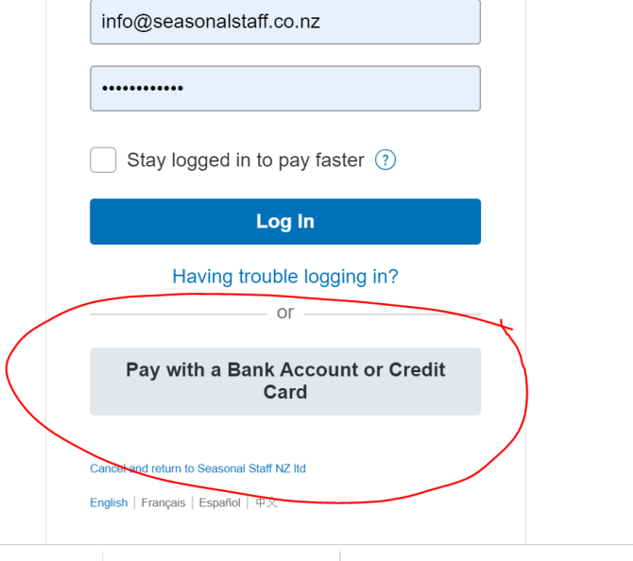

1. EThismployers are also saying that the " pay by bank account or credit card" is too far down and they dont see it. Can this be shifted up so it is easier to see.... it always seems to out of their view can this be shifted up please

3 This part of paypal is not necessary can we remove please.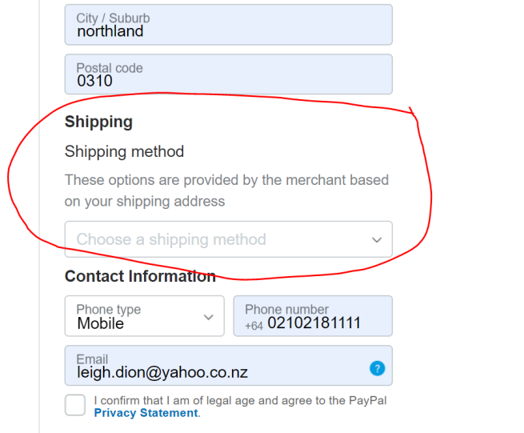

4. Is it possible to not have this pop up from paypal please.

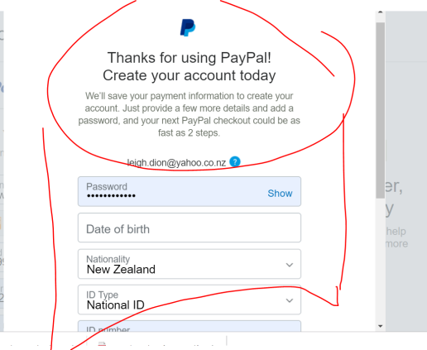

5. Can we please change the wording of this pop up to "First, Lets get you set up" and underneath change the wording to "Setting up your business profile in important & will only take a minute" -> **done**

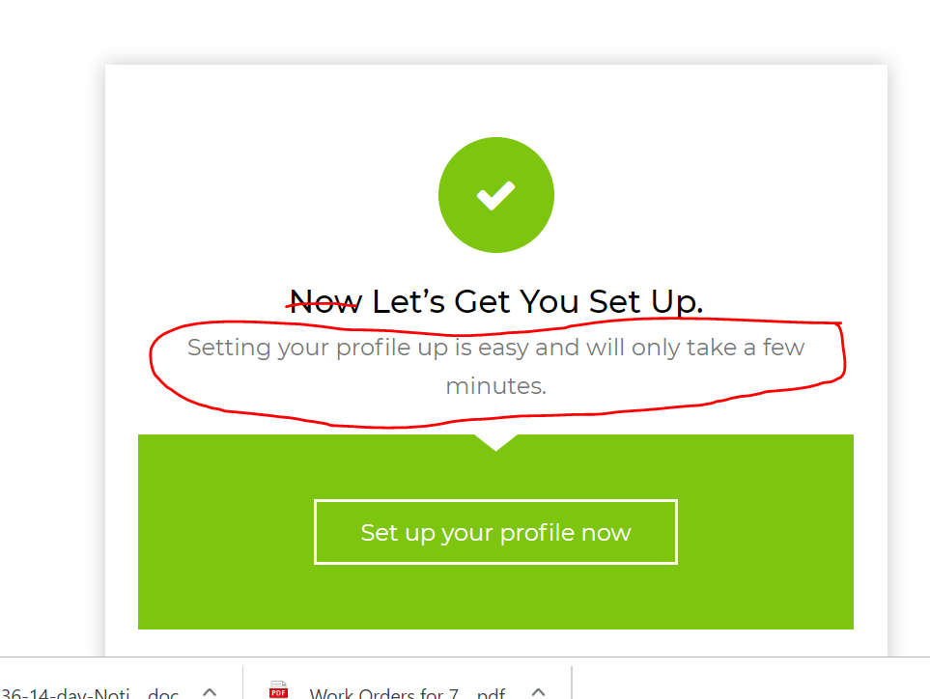

6. Please can this message be removed as it is extra that does not need to be there.. -> **done**

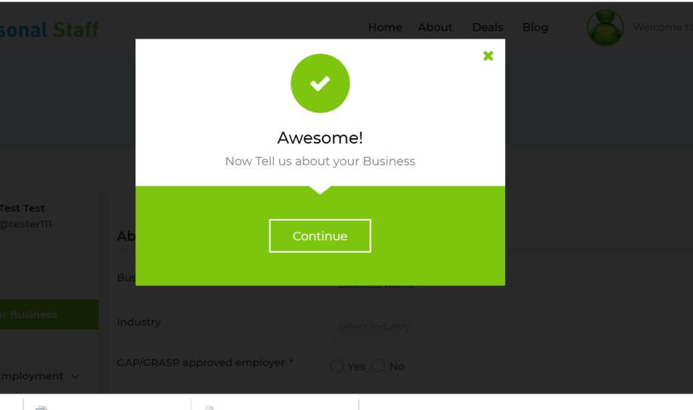

7. On the profile page "Select Industry " is light grey.... but all the rest are dark type. Can all the writing in the feilds that are underlined be in the "light grey"

8. Where it says "Main Business location" please can that wording be changed to "Select your business address from dropdown menu " - In light grey writting please -> **done**

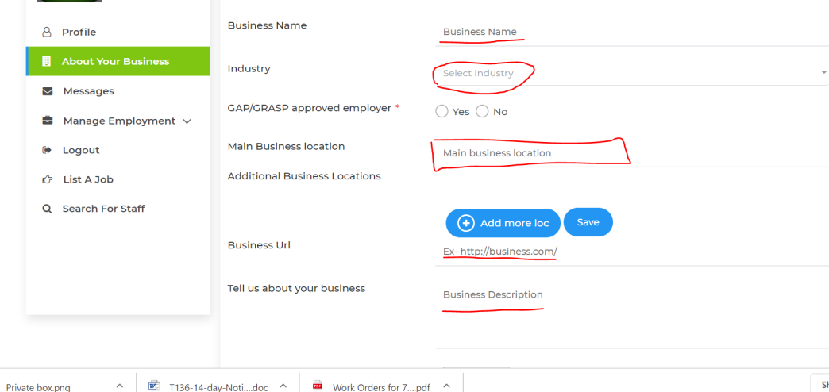

9. Also can the "save" button move move up It is out of site and the button be bigger. -> **done**

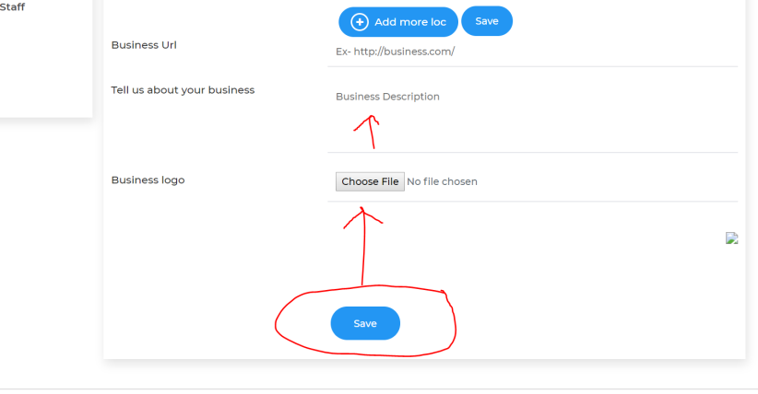

10. Same here can the Save button be moved up as it is out of the picture. Can you please make the button bigger also.

11. Can the wording be changed here form “ Hello, xxxx “ to “Fantastic, your all set up” then change the other wording to “ Now tell us what you want to do” -> **done**

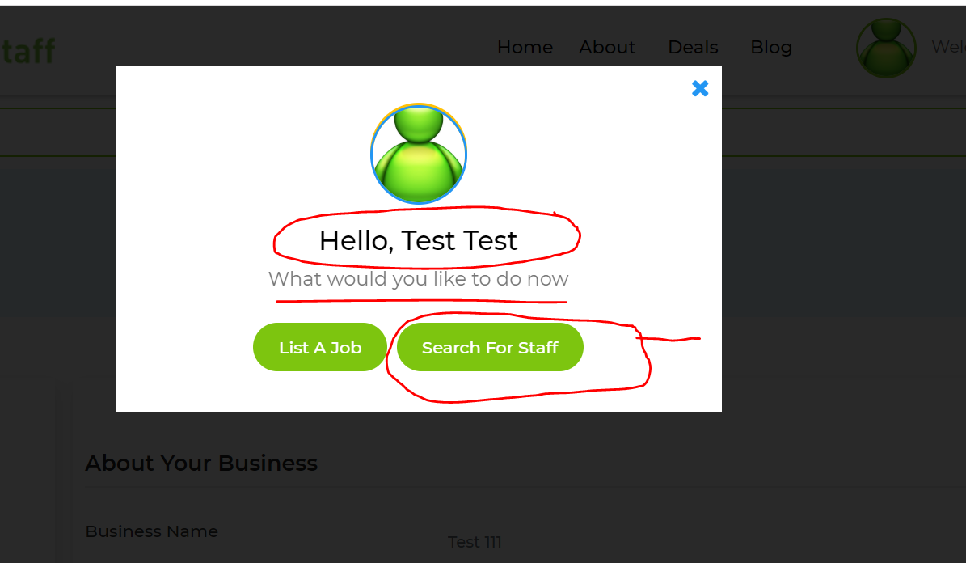

If they hit the “Search for Staff “ button they are taken to this screen (see below) This is correct

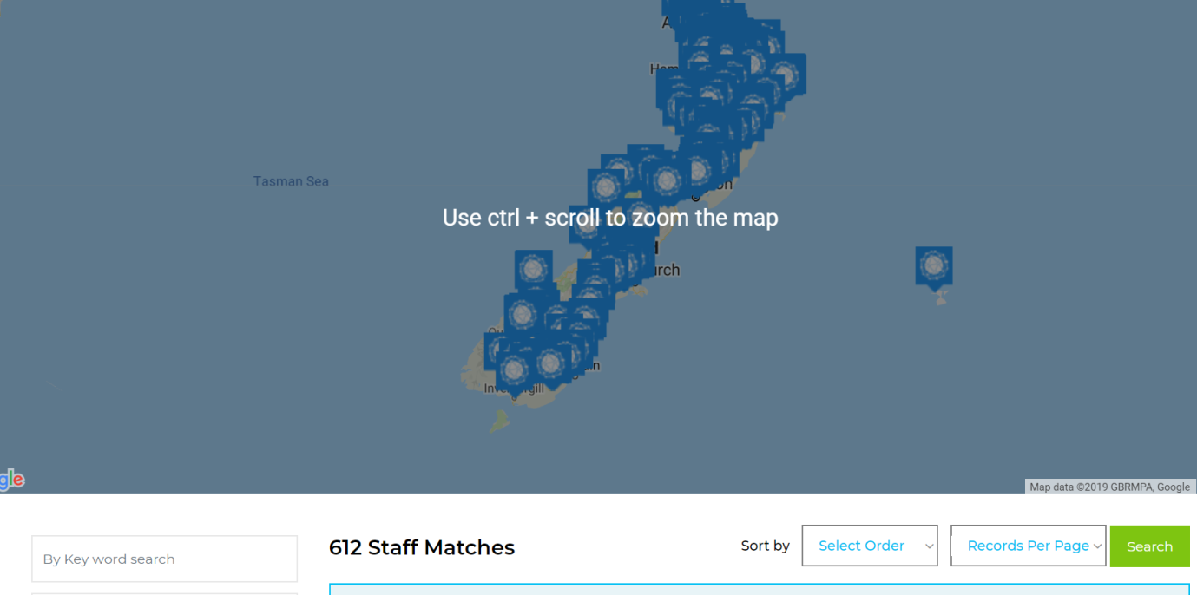

However can we have a pop up box appear to say “ Did you know you can search for staff by Industry experience or by licences or skill? “ “ Do this by using the menu below” Can there be be a box on the pop up window to say “ Ok, Got it” that will

If the select the Employer selects “list a job box (below) it will take them to the “ list a job” page – This is correct.

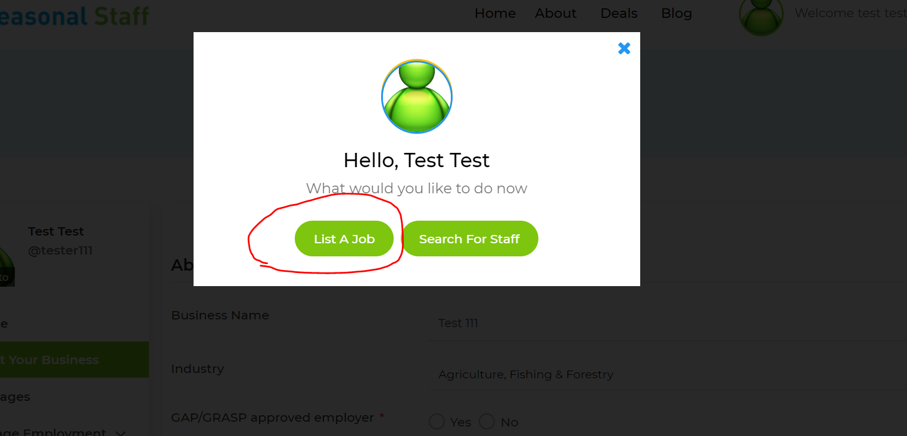

section” Can this pop up please say “ Manage and view all your jobs and applicants from the Manage Employment tab”

